**Minutes**

**Joint City/County SPLOST Meeting**

**May 23, 2024**

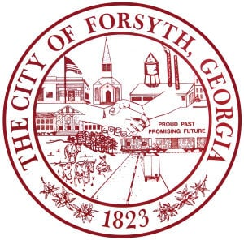**No Quorum**