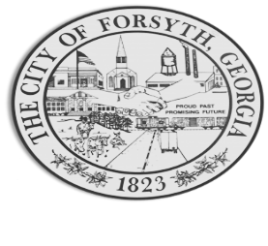

Agenda
Forsyth Council Meeting
May 1, 2023
23 E. Main Street 6:00 p.m.

- Call to Order
- Pledge of Allegiance, Invocation by Marilyn Tucker, and Roll Call
- Approval of the agenda.
- Approval of the minutes from the council meeting held on April 3, 2023.
- Approval of a fourth amendment to an intergovernmental agreement with the City of Adel.
- Approval to accept a proposed consent order from Environmental Protection Division and payment of the calculated penalty.

- Approval of renewal agreements with Cummins Sales and Service.

- Approval of a contract for probation supervision services with CSRA Probation Services, Inc.

- Approval of the ballot for GMA’s District 6 Officers for 2023-2024.

- Approval of a street closure request from Patreecia Simmons on July 15, 2023, 6th Annual James Street Day.

- Walter Goodson

- Street Closure for Main Street Concerts and Events

- Approval of Requisitions Greater than $6,000
- Davis Plumbing $9,735.00
- Goforth Williamson $34,825.00

- City Manager’s Report
- City Attorney Report
- Mayor’s Report
- Additional Business
- Public Comments
- Executive Session
- Adjourn
Individuals with disabilities who require certain accommodations to allow them to observe and/or participate in this meeting, or who have questions regarding the accessibility of Aldermen Hall can contact the City Clerk, Regina Ivie at 478-994-5649 or rivie@cityofforsyth.com. If additional accommodation is needed requests should be made as soon as possible but no less than 24 hours prior to the scheduled meeting.

