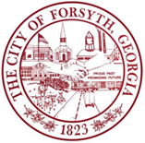

Joint City/County Meeting
Wednesday December 17, 2025 at 6:00p.m.
Monroe County Administration Building
38 West Main Street, Forsyth, GA 31029

- Roll Call
- Call to Order
- Approval of the agenda
- Discussion
- City Council Comments
- Adjourn

