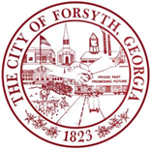

**Joint City / County Meeting**

**Thursday, May 23, 2024**

**9:00a.m**.

1. **Call to Order**
2. **Approval of agenda**
3. **Discussion of SPLOST Projects**
4. **Discussion of Intergovernmental Agreement for the 2026-2031 SPLOST**
5. **Adjourn**

|  |  |
| --- | --- |
|  | Roll Call |
|  | Mayor Eric Wilson |
|  | Councilman Dodd |
|  | Councilman Hewett |
|  | Councilman Goolsby |
|  | Councilwoman Allen |
|  | Councilman Wilder |
|  | Councilman Hill |
|  |  |
|  |  |