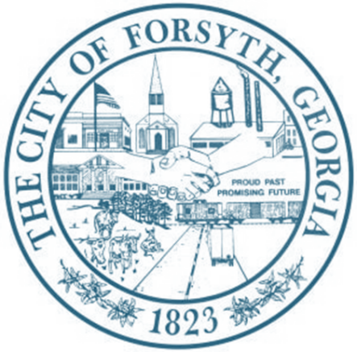

Called Meeting Agenda
August 19, 2024 @ 5:30p.m.

- Call to Order

- Appeal for minor plat denial.

- Adjourn

