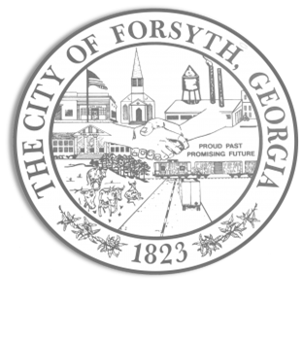

**Agenda**

**Forsyth City Council Meeting**

**September 5, 2023**

**23 East Main Street @ 6:00 p.m.**

1. **Call to Order**
2. **Pledge of Allegiance, Invocation by Lloyd Strickland, and Roll Call**
3. **Approval of the agenda**
4. **Approval of the minutes from the council meeting held on August 21, 2023.**
5. **Approval to apply for a One Georgia Rural Workforce Housing Grant.**
6. **Approval to proceed with bid process for Indian Springs Water Line Replacement Project.**
7. **Approval of an emergency purchase of a belt press for the South Wastewater treatment Plant.**
8. **Approval of an appointment to the Planning & Zoning Commission.**
9. **Approval of a request by Will Davis to hold a debate on Monday, September 25th from 6 p.m. to 8 p.m.**
10. **Approval of a street closure request for the Bank of Dudley during construction.**
11. **Walter Goodson**
12. **Update - E911 – Upgrade & Redundancy**
13. **Tabled agenda items from August 21, 2023 meeting:**
14. **City Court location possibilities**
15. **GDOT Roundabout Project**

**Approval of indication of roundabout support from Department of Transportation.**

1. **Approval of Requisitions Greater than $6,000**
2. **Industrial Chemicals, Inc $15,187.50**
3. **City Manager’s Report**
4. **City Attorney Report**
5. **Mayor’s Report**
6. **Council Board Reports**
7. **Additional Business**
8. **Public Comments**
9. **Executive Session**
10. **Adjourn**

**Individuals with disabilities who require certain accommodations to allow them to observe and/or participate in this meeting, or who have questions regarding the accessibility of City Hall can contact the City Clerk, Regina Ivie at 478-994-5649 or rivie@cityofforsyth.com. If additional accommodations are needed requests should be made as soon as possible but no less than 24 hours prior to the scheduled meeting.**