Agenda
Forsyth City Council Meeting
September 3, 2024
23 East Main Street @ 6:00 p.m.

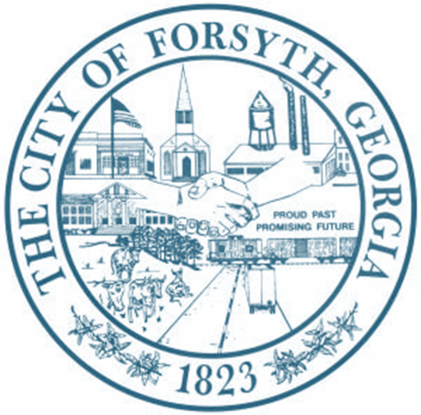

- Call to Order
- Pledge of Allegiance, Invocation and Roll Call
- Approval of the agenda
- Approval of the minutes from the called meeting and council meeting held on August 19, 2024
- Public Hearing to consider a variance request regarding Article 10, Non-residential Zoning Districts,
Table 10.1
- Approval of Common Use Agreement between Georgia Power Company and the City of Forsyth
- Approval to set millage rate
- Walter Goodson
- Approval of Requisitions Greater than $6,000
- Goforth Williamson, Inc. - $19,850.00

- City Manager’s Report
- City Attorney Report
- Mayor’s Report
- Council Board Reports
- Additional Business
- Public Comments
- Executive Session
- Adjourn

Individuals with disabilities who require certain accommodations to allow them to observe and/or participate in this meeting, or who have questions regarding the accessibility of City Hall can contact the City Clerk, Regina Ivie at 478-994-5649 or rivie@cityofforsyth.com. If additional accommodations are needed requests should be made as soon as possible but no less than 24 hours prior to the scheduled meeting.

