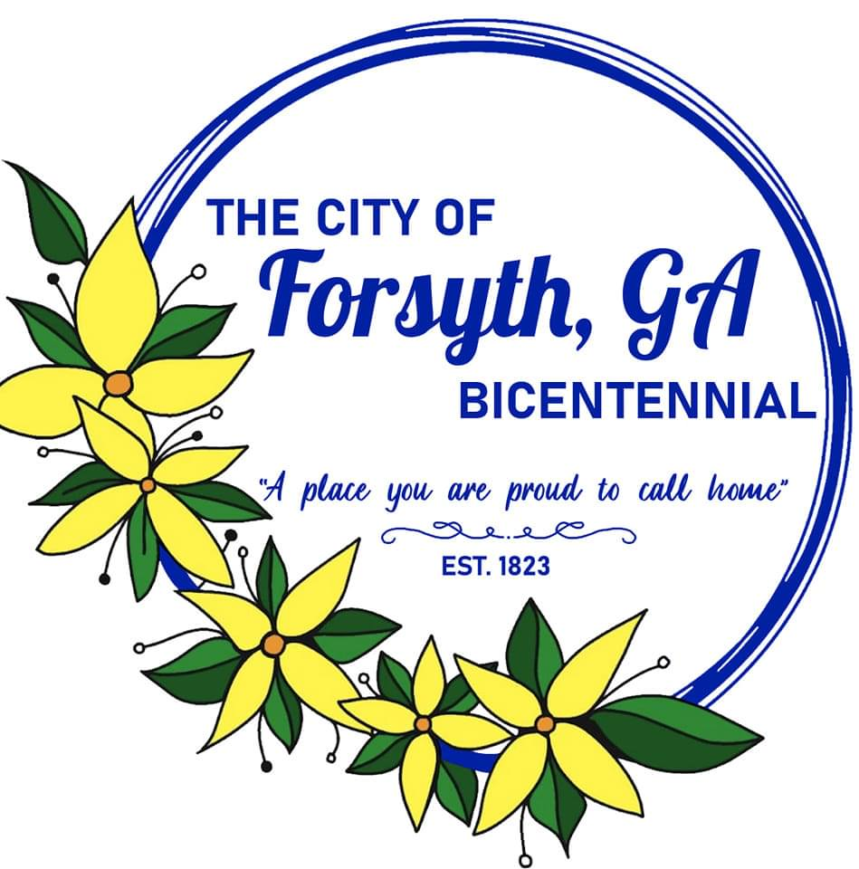
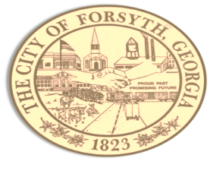

Agenda
Forsyth City Council Meeting
September 18, 2023 @ 6:00 p.m.

- Call to Order
- Pledge of Allegiance, Invocation by Carol Cook, and Roll Call
- Approval of the agenda.
- Approval of the minutes from the council meeting held on September 5, 2023.
- Bicentennial Celebration Update by Gilda Stanbery.
- Approval of a temporary permit for the sale of alcoholic beverages for El Dorado Mexican Restaurant.
- Approval of a temporary permit for the sale of alcoholic beverages for Fall Line Brewing Company.
- Approval of proposal to revise city ordinance governing temporary alcohol licensing.
- Update on landscape needs in downtown area.
- Georgia Department of Transportation Project 0017177
- Davenport Public Finance, Doug Gebhardt to review investment options for funds at Truist Bank.
- Approval of the The GOV App proposal.
- Tabled agenda items from the 9-5-23 council meeting.
- Bank of Dudley – Street Closure request.
- Walter Goodson – unmaintained street from Powell to Sharp.

- Approval of Requisitions Greater than $6,000
- Gresco - $15,483.68
- Davis Plumbing – $49,873.00

- City Manager’s Report
- City Attorney Report
- Mayor’s Report
- Additional Business
- Public Comments
- Executive Session (if necessary)
- Adjourn
Individuals with disabilities who require certain accommodations to allow them to observe and/or participate in this meeting, or who have questions regarding the accessibility of Aldermen Hall can contact the City Clerk, Regina Ivie at 478-994-5649 or rivie@cityofforsyth.com. If additional accommodation is needed requests should be made as soon as possible but no less than 24 hours prior to the scheduled meeting.

