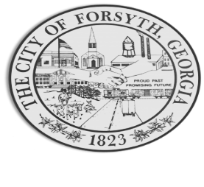

Agenda
August 21, 2023
Forsyth Council Meeting

- Call to Order
- Pledge of Allegiance, Invocation by David Blalock, and Roll Call
- Approval of the agenda.
- Approval of the minutes from the called meeting and regular council meeting held on August 7, 2023.
- Bicentennial Proclamation
- Pastor Miller – Aldermen Hall Discussion
- Public hearing to consider a variance request application by Josh Hill for 3 lots totaling 1.5 acres, tax parcel 054 019.
- Public hearing to consider a rezoning request by the city for one parcel totaling 17.75 acres, tax parcel 054 009X.
- Approval of indication of roundabout support from Department of Transportation.
- Approval of appointments to the Main Street/Downtown Development Authority Board.
- Approval of a street closure request for the 2023 Mary Person High School Homecoming Parade on Sept. 28th.
- Approval of an event permit and standard location release for TLC’s 7 Little Johnston’s show.
- Approval of a permit for a group assembly by Life Chain on October 1, 2023.
- Approval of a street closure request for Fox City/Jonah’s on October 7, 2023.
- Approval of Requisitions Greater than $6,000
- Core & Main - $54,282.50
- Georgia Hydrant - $7,000

- City Manager’s Report
- City Attorney Report
- Mayor’s Report
- Additional Business
- Public Comments
- Executive Session (if necessary)
- Adjourn
Individuals with disabilities who require certain accommodations to allow them to observe and/or participate in this meeting, or who have questions regarding the accessibility of Aldermen Hall can contact the City Clerk, Regina Ivie at 478-994-5649 or rivie@cityofforsyth.com. If additional accommodations are needed requests should be made as soon as possible but no less than 24 hours prior to the scheduled meeting.

