**Agenda**

**Forsyth City Council Meeting**

**Monday, August 19, 2024**

**23 East Main Street @ 6:00 p.m.**

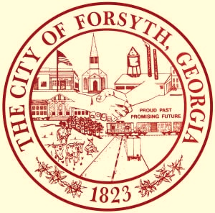

1. **Call to Order**
2. **Pledge of Allegiance, Invocation, and Roll Call**
3. **Approval of the agenda.**
4. **Approval of the minutes from the council meeting held on August 5, 2024.**
5. **Approval of Vibrant Community Art Grant by Gilda Stanbury and Denise Buff.**
6. **Discussion of the 2024 Fall Festival and approval of a street closure request on**

**September 28, 2024.**

1. **Approval of the water service tap fees**
2. **Set tentative millage rate and approval to advertise for Public Hearing**
3. **2024 YTD Financial Review**
4. **Approval of Requisitions Greater than $6,000**

* **Industrial Chemicals, Inc. - $14,998.50**

1. **City Manager’s Report**
2. **City Attorney Report**
3. **Mayor’s Report**
4. **Additional Business**
5. **Public Comments**
6. **Executive Session**
7. **Adjourn**

**Individuals with disabilities who require certain accommodations to allow them to observe and/or participate in this meeting, or who have questions regarding the accessibility of Aldermen Hall can contact the City Clerk, Regina Ivie at 478-994-5649 or rivie@cityofforsyth.com. If additional accommodations are needed requests should be made as soon as possible but no less than 24 hours prior to the scheduled meeting.**