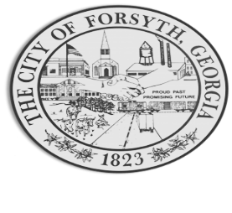

Agenda
July 24, 2023
Forsyth Council Meeting

- Call to Order
- Pledge of Allegiance, Invocation by Joe Thompson, and Roll Call
- Approval of the agenda.
- Approval of the minutes from the council meeting held on June 5, 2023 and the called meeting on July 5, 2023.
- Main Street Update – Kemie Childs
- Approval of police department renovations – Officer Asbell & Investigator Thomas.

- Approval of turnout gear equipment purchase – Chief Bunn.

- Gilda Stanbery – Bicentennial Update
- Approval of street closure request for the event.

- Hofstadter & Associates Project Updates
- Montpelier Road
- Park Plan
- Sewer Discharge
- Indian Springs Water line upgrade.

- Appointment to fill vacancy for Post 3 council seat.
- Set tentative millage rate and approval to advertise for a public hearing.
- Discussion of Georgia Initiative for Community Housing (GICH).

- Approval of Requisitions Greater than $6,000
- Calibration Controls Automation Inc. $12,658.56
- U-Tec Construction, Inc $16,660.00
- Calibration Controls Automation Inc. $6,960.00

- Assistant City Manager’s Report
- City Manager Report – Funding for outstanding projects.
- City Attorney Report
- Mayor’s Report
- Additional Business
- Public Comments
- Executive Session
- Adjourn

Individuals with disabilities who require certain accommodations to allow them to observe and/or participate in this meeting, or who have questions regarding the accessibility of Aldermen Hall can contact the City Clerk, Regina Ivie at 478-994-5649 or rivie@cityofforsyth.com. If additional accommodations are needed requests should be made as soon as possible but no less than 24 hours prior to the scheduled meeting.

