**Agenda**

**Forsyth City Council Meeting**

**July 1, 2024**

**23 East Main Street @ 6:00 p.m.**

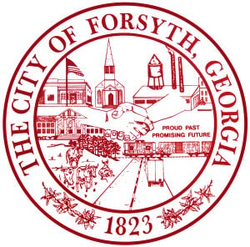

1. **Call to Order**
2. **Pledge of Allegiance, Invocation and Roll Call**
3. **Approval of the agenda**
4. **Approval of the minutes from the called meeting and council meeting held on June 17, 2024.**
5. **Approval of Eagle Scout Project for Milledge Circle Park by James Pippin**
6. **Tabled agenda item from June 17, 2024 council meeting**

* **Public hearing to consider Annexation of certain properties and Zoning after annexation, and Rezoning of certain properties within the city; George Emami- Prime Point Ventures, LLC and Hiram Harbuck- Blake Ventures, LLC**

1. **Public Hearing to consider Side-by-Side All-Terrain Ordinance**
2. **Approval of the Georgia Municipal Employee Benefit System Defined Retirement Plan Restatement**

**and all documents related**

1. **Discussion of freestanding pylon signage**
2. **Approval of Requisitions Greater than $6,000**

* **Etheridge Heating & A/C, INC - $7000.00**

1. **City Manager’s Report**
2. **City Attorney Report**
3. **Mayor’s Report**
4. **Council Board Reports**
5. **Additional Business**
6. **Public Comments**
7. **Executive Session**
8. **Adjourn**

**Individuals with disabilities who require certain accommodations to allow them to observe and/or participate in this meeting, or who have questions regarding the accessibility of City Hall can contact the City Clerk, Regina Ivie at 478-994-5649 or rivie@cityofforsyth.com. If additional accommodations are needed requests should be made as soon as possible but no less than 24 hours prior to the scheduled meeting.**