**Agenda**

**Forsyth City Council Meeting**

**June 3, 2024**

**23 East Main Street @ 6:00 p.m.**

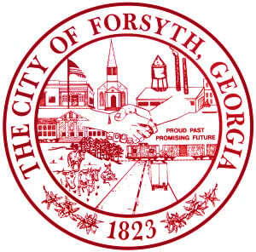

1. **Call to Order**
2. **Pledge of Allegiance, Invocation and Roll Call**
3. **Approval of the agenda**
4. **Approval of the minutes from the council meeting held on May 20, 2024.**
5. **Approval of street closure request on June 29, 2024 by John Walton**
6. **Approval of BKS insurance brokers**
7. **Approval of the Intergovernmental Agreement for the 2026-2031 SPLOST**
8. **Approval of the Municipal Electric Authority of Georgia’s Telecommunications year end settlement.**
9. **Walter Goodson**
10. **Approval of a 4-Way Stop at the intersections of E. Johnston Street at N. Harris Street and E. Johnston Street**

**at N. Kimbell Street.**

1. **Approval of Surplus Vehicles**
2. **Approval of called meeting on June 17, 2024 at the City Annex to discuss the Convention & Visitors Bureau**
3. **Approval of an event permit and standard location release for TLC’s 7 Little Johnston’s show.**
4. **2024 Financial Review**
5. **Approval of Requisitions Greater than $6,000**

* **Davis Plumbing Company - $24,687.00**
* **Davis Plumbing Company - $23,702.00**

1. **City Manager’s Report**
2. **City Attorney Report**
3. **Mayor’s Report**
4. **Council Board Reports**
5. **Additional Business**
6. **Public Comments**
7. **Executive Session**
8. **Adjourn**

**Individuals with disabilities who require certain accommodations to allow them to observe and/or participate in this meeting, or who have questions regarding the accessibility of City Hall can contact the City Clerk, Regina Ivie at 478-994-5649 or rivie@cityofforsyth.com. If additional accommodations are needed requests should be made as soon as possible but no less than 24 hours prior to the scheduled meeting.**