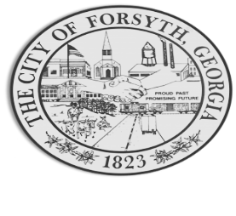

Agenda
Forsyth Council Meeting
June 20, 2023
23 E. Main Street 6:00 p.m.

- Call to Order
- Pledge of Allegiance, Invocation by Lloyd Strickland, and Roll Call
- Approval of the agenda.
- Approval of the minutes from the council meeting, work session held on June 5, 2023 and called council meeting held on June 14, 2023.

- Main Street Update – Kemie Childs, Main Street Coordinator.
- Approval of Monroe County Amateur Radio Society request on June 24, 25, 2023 and a proclamation presentation.

- Appointment of an alternate voting delegate for the Municipal Electric Authority of Georgia’s Election Committee.

- Approval of Requisitions Greater than $6,000
- Axon Enterprise, Inc $8,188.56
- Interceptor Public Safety $7,168.50

- Assistant City Manager’s Report
- City Attorney Report
- Mayor’s Report
- Additional Business
- Public Comments
- Executive Session
- Adjourn

Individuals with disabilities who require certain accommodations to allow them to observe and/or participate in this meeting, or who have questions regarding the accessibility of Aldermen Hall can contact the City Clerk, Regina Ivie at 478-994-5649 or rivie@cityofforsyth.com. If additional accommodations are needed requests should be made as soon as possible but no less than 24 hours prior to the scheduled meeting.

