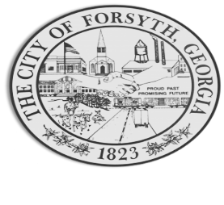

Agenda
Forsyth Council Meeting
April 24, 2023
@ Board of Education Auditorium 10:00 a.m.

- Call to Order
- Pledge of Allegiance, Invocation by, and Roll Call
- Approval of the agenda.
- Approval of the minutes from the council meeting held on April 3, 2023.
- Approval of a fourth amendment to an intergovernmental agreement with the City of Adel.
- Approval to accept a proposed consent order from Environmental Protection Division and payment of the calculated penalty.

- Approval of renewal agreements with Cummins Sales and Service.

- Approval of Requisitions Greater than $6,000
- Davis Plumbing $9,735.00
- Goforth Williamson $34,825.00

- City Manager’s Report
- City Attorney Report
- Mayor’s Report
- Additional Business
- Public Comments
- Executive Session
- Adjourn

Individuals with disabilities who require certain accommodations to allow them to observe and/or participate in this meeting, or who have questions regarding the accessibility of Aldermen Hall can contact the City Clerk, Regina Ivie at 478-994-5649 or rivie@cityofforsyth.com. If additional accommodations are needed requests should be made as soon as possible but no less than 24 hours prior to the scheduled meeting.

