**Agenda**

**Forsyth City Council Meeting**

**March 3, 2025**

**23 East Main Street @ 6:00 p.m.**

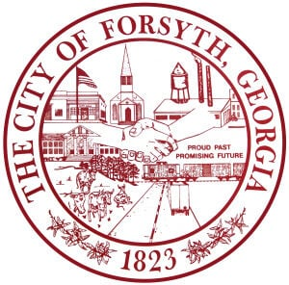

1. **Call to Order**
2. **Pledge of Allegiance, Invocation and Roll Call**
3. **Approval of the agenda**
4. **Approval of the minutes from the Council Meeting held on February 17, 2025.**
5. **Introduction of Rachel Floyd, the Community Development Communications Coordinator.**
6. **Approval of a street closure request on March 22, 2025 for the 8th Annual Fit to Achieve 5k race.**
7. **Development Issue- George Emami**
8. **Adoption of the City of Civility Resolution**
9. **Approval to cancel the March 17, 2025 council meeting.**
10. **Approval of the 2024 Budget Adjustments**
11. **City Manager’s Report**
12. **City Attorney Report**
13. **Mayor’s Report**
14. **Council Board Reports**
15. **Additional Business**
16. **Public Comments**
17. **Executive Session (if necessary)**
18. **Adjourn**

**Individuals with disabilities who require certain accommodations to allow them to observe and/or participate in this meeting, or who have questions regarding the accessibility of City Hall can contact the City Clerk, Shayla Furlow at 478-994-5649 or sfurlow@cityofforsyth.com. If additional accommodations are needed requests should be made as soon as possible but no less than 24 hours prior to the scheduled meeting.**