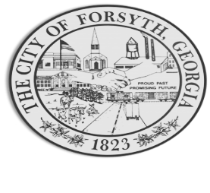

Agenda
Forsyth Council Meeting
March 20, 2023 6:00 p.m.

- Call to Order
- Pledge of Allegiance, Invocation by Cleveland Jarrell, and Roll Call
- Approval of the agenda.
- Approval of the minutes from the council meeting held on March 6, 2023.
- Convention & Visitors Bureau Quarterly report by Gilda Stanbery
- Approval to change the signatures for Municipal Competitive Trust.
- Approval of year end 2022 budget adjustments.
- Approval of request for traffic signal with Georgia Department of Transportation.
- Approval of an agreement with and payment to i3-SSI
- Approval of Requisitions Greater than $6,000
- Interceptor Public Safety Products $6,739.57
- Billings Welding LLC $6,079.00
- Industrial Chemicals $15,187.50
- Davis Plumbing $11,740.00

- City Manager’s Report
- Mayor’s Report
- Additional Business
- Public Comments
- Executive Session
- Adjourn

Individuals with disabilities who require certain accommodations to allow them to observe and/or participate in this meeting, or who have questions regarding the accessibility of Aldermen Hall can contact the City Clerk, Regina Ivie at 478-994-5649 or rivie@cityofforsyth.com. If additional accommodations are needed requests should be made as soon as possible but no less than 24 hours prior to the scheduled meeting.

