Agenda
Forsyth City Council Meeting
March 16, 2026
23 East Main Street @ 6:00 p.m.

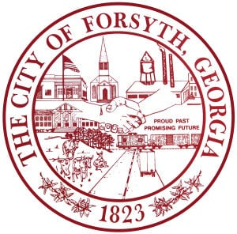

- Call to Order
- Pledge of Allegiance, Invocation, and Roll Call
- Approval of the agenda.
- Approval of the minutes from the council meeting held on March 2, 2026.
- Presentation of the Extraordinary Action Medals.
- Approval of a Memorandum of Understanding between the City of Forsyth and the Historical Society.
- Approval of a bid award to Dixie Lawn & Landscaping for downtown landscaping.
- Approval of additional funding for the Public Works/Utilities Facility Project.
- Approval of FY2025 Budget Adjustments
- Approval of Requisitions Greater than $6,000
- Calibration Controls Automation, Inc.- $11,769.96
- Davis Plumbing Co.- $11,494.00
- Roberts Hauling and Pipeline Construction, Inc.- $13,500.00

- City Manager’s Report
- City Attorney Report
- Mayor’s Report
- Additional Business
- Public Comments
- PFAS Class Action Litigation
- Executive Session (litigation)
- Adjourn

Individuals with disabilities who require certain accommodations to allow them to observe and/or participate in this meeting, or who have questions regarding the accessibility of City Hall can contact the City Clerk, Shayla Furlow at 478-994-5649 or sfurlow@cityofforsyth.com. If additional accommodations are needed requests should be made as soon as possible but no less than 24 hours prior to the scheduled meeting.

