**Agenda**

**Forsyth City Council Meeting**

**February 3, 2025**

**23 East Main Street @ 6:00 p.m.**

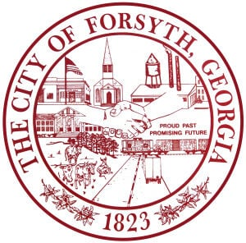

1. **Call to Order**
2. **Pledge of Allegiance, Invocation and Roll Call**
3. **Approval of the agenda**
4. **Approval of the minutes from the council meeting held on January 6, 2025 and public hearings held on January**

**23 and 30, 2025.**

1. **Approval of street closure request on March 1, 2025 for the Forsythia 5k race**
2. **Approval of street closure request on March 7-9, 2025 for the Forsythia Festival**
3. **House Bill 581**
4. **Tabled agenda item from January 6, 2025 council meeting**

* **Planning and Zoning Commission Board Appointment**

1. **Walter Goodson**
2. **Approval of Requisitions Greater than $6,000**

* **Reed & Shows Meter Repair & Supply Co. – 13,500.00**

1. **City Manager’s Report**
2. **City Attorney Report**
3. **Mayor’s Report**
4. **Council Board Reports**
5. **Additional Business**
6. **Public Comments**
7. **Executive Session (Real Estate)**
8. **Adjourn**

**Individuals with disabilities who require certain accommodations to allow them to observe and/or participate in this meeting, or who have questions regarding the accessibility of City Hall can contact the City Clerk, Shayla Furlow at 478-994-5649 or sfurlow@cityofforsyth.com. If additional accommodations are needed requests should be made as soon as possible but no less than 24 hours prior to the scheduled meeting.**