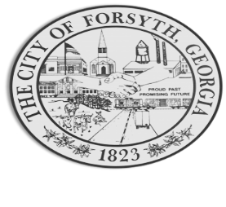

Agenda
February 20, 2023
Forsyth Council Meeting
23 E. Main Street

- Call to Order
- Pledge of Allegiance, Invocation by David Blalock, and Roll Call
- Approval of the agenda.
- Approval of the minutes from the work session held on February 6, 2023.
- Herbert Gantt, Winifred Berry, and Tammy Selman with Hubbard Alumni.
- Approval of an application for the sale of alcoholic beverages at Old Mill Market (beer/malt pouring, and wine pouring).
- Approval of an application from Forsyth-Monroe Co. Chamber of Commerce for the issuance of a temporary permit for the sale of alcoholic beverages at Monroe County Conference Center on 2/25/2023.
- Approval of an application from Forsyth-Monroe Co. Chamber of Commerce for the issuance of a temporary permit for the consumption only on the premises of beer, wine, or liquor on March 10, 2023.

- Approval of an agreement with Department of Transportation.
- Approval of revisions to the dress code policy for administrative employees.
- Walter Goodson
- City Manager’s Report
- City Attorney Report
- Mayor’s Report
- Additional Business
- Public Comments
- Executive Session
- Adjourn

Individuals with disabilities who require certain accommodations to allow them to observe and/or participate in this meeting, or who have questions regarding the accessibility of Aldermen Hall can contact the City Clerk, Regina Ivie at 478-994-5649 or rivie@cityofforsyth.com. If additional accommodations are needed requests should be made as soon as possible but no less than 24 hours prior to the scheduled meeting.

