Agenda
Forsyth City Council Meeting
February 2, 2026
23 East Main Street @ 6:00 p.m.

- Call to Order
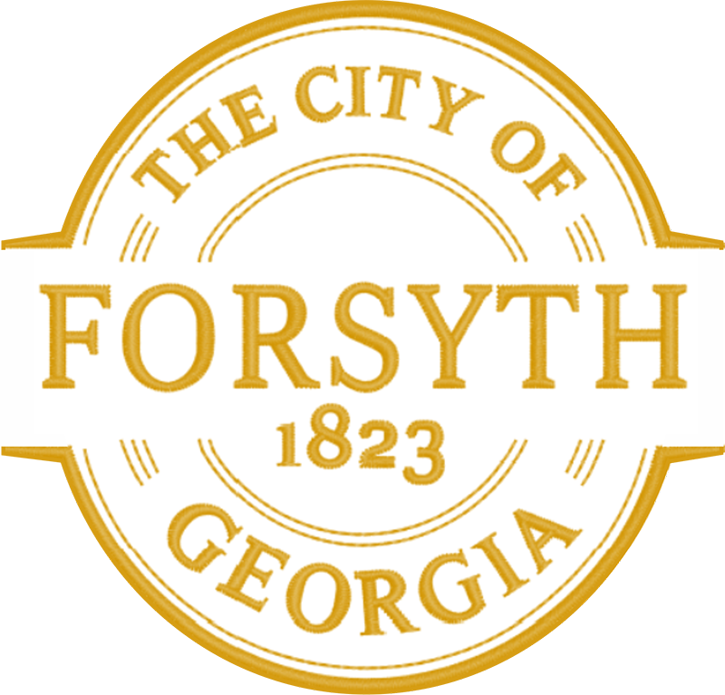
- Pledge of Allegiance, Invocation and Roll Call
- Swearing in of Councilmember Glynn Holmes, Sr.
- Approval of the agenda.
- Approval of the minutes from the council meeting held on January 20, 2025.
- Consideration of a Request from Todd Ussery, Acorn, LLC
- Public Hearing for consideration to rezone parcels 026 020, 015 005, 015 005A, and 015 005B to Agricultural,
AGR, and a Conditional Use Application for data Centers and Substations for H&H Timberlands, LLC.
- Approval of a Resolution Appointing Two Officials to Communicate City Decisions to the Municipal
Electric Authority of Georgia TRUST.
- Approval of a Resolution Appointing a Voting Delegate and an Alternate Voting Delegate on the Municipal
Electric Authority of Georgia’s Election Committee.
- Approval of a Resolution Appointing a Voting Delegate and an Alternate to Communicate Decisions of the
Participant to Electric Cities of Georgia regarding Board of Directors of ECG Election Process.
- Approval of a Resolution Appointing an Authorized Official and an Alternate to Communicate Decisions of
the Participant to Electric Cities of Georgia, Inc.
- Tabled agenda item from January 2, 2026 council meeting.
- Monroe County Health Board Appointment
- City Manager’s Report
- City Attorney Report
- Mayor’s Report
- Council Board Reports
- Additional Business
- Public Comments
- Executive Session (if necessary)
- Adjourn

Individuals with disabilities who require certain accommodations to allow them to observe and/or participate in this meeting, or who have questions regarding the accessibility of City Hall can contact the City Clerk, Shayla Furlow at 478-994-5649 or sfurlow@cityofforsyth.com. If additional accommodations are needed requests should be made as soon as possible but no less than 24 hours prior to the scheduled meeting.

