Agenda
Forsyth City Council Meeting
February 16, 2026
23 East Main Street @ 6:00 p.m.

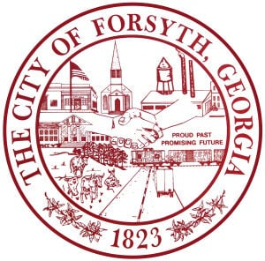

- Call to Order
- Pledge of Allegiance, Invocation, and Roll Call
- Approval of the agenda.
- Approval of the minutes from the council meeting held on February 2, 2026.
- Approval of a street closure request on March 7, 2026 for the Forsythia Kickoff.
- Convention & Visitors Bureau Authority’s quarterly report by Gilda Stanbery.
- Appointment to the Planning and Zoning Commission.
- Consideration on amending the City of Forsyth holiday schedule to include Good Friday.
- First reading of Rezoning and Conditional Use Ordinance for parcels comprising the
proposed Forsyth Technology Campus.

- Sharp Street Sewer Main Extension
- Approval of an Intergovernmental Agreement with Monroe County for imposition of the
Floating Homestead Local Option Sales Tax (FLOST).
- City Manager’s Report
- City Attorney Report
- Mayor’s Report
- Additional Business
- Public Comments
- Executive Session (if necessary)
- Adjourn

Individuals with disabilities who require certain accommodations to allow them to observe and/or participate in this meeting, or who have questions regarding the accessibility of City Hall can contact the City Clerk, Shayla Furlow at 478-994-5649 or sfurlow@cityofforsyth.com. If additional accommodations are needed requests should be made as soon as possible but no less than 24 hours prior to the scheduled meeting.

