**Agenda**

**Forsyth City Council Meeting**

**December 2, 2024**

**23 East Main Street @ 6:00 p.m.**

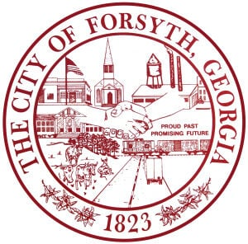

1. **Call to Order**
2. **Pledge of Allegiance, Invocation and Roll Call**
3. **Approval of the agenda**
4. **Approval of the minutes from the council meeting held on November 18, 2024**
5. **Convention & Visitors Bureau Proposal**
6. **Adoption of the resolution for the 2025 budget**
7. **Approval of the off-system energy sales margins for the power supply year 2025**
8. **Middle Georgia Regional Commission Council Appointments- Monroe County**
9. **Approval of bid award to East Coast Grading**
10. **Approval of bid award to Roberts Hauling**
11. **Approval of Requisitions Greater than $6,000**

* **NAFECO - $53,745.00**
* **Core & Main, LP - $20,527.84**
* **Fisher Scientific Company, LLC - $10,524.18**

1. **City Manager’s Report**
2. **City Attorney Report**
3. **Mayor’s Report**
4. **Council Board Reports**
5. **Additional Business**
6. **Public Comments**
7. **Executive Session**
8. **Adjourn**

**Individuals with disabilities who require certain accommodations to allow them to observe and/or participate in this meeting, or who have questions regarding the accessibility of City Hall can contact the City Clerk, Regina Ivie at 478-994-5649 or rivie@cityofforsyth.com. If additional accommodations are needed requests should be made as soon as possible but no less than 24 hours prior to the scheduled meeting.**