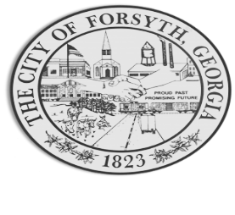
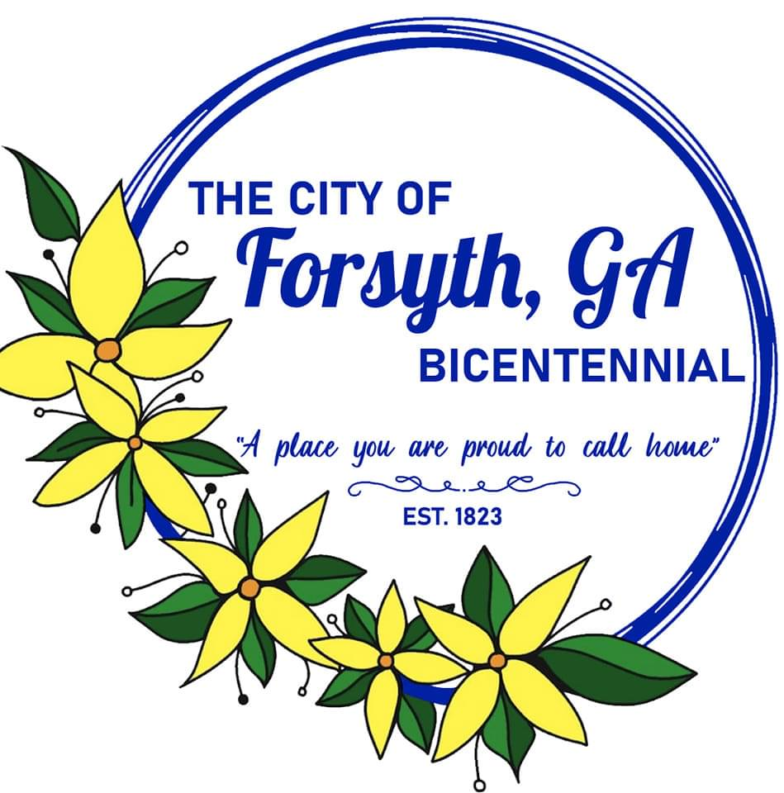
Agenda
Forsyth City Council Meeting
December 18, 2023
23 East Main Street @ 6:00 p.m.

- Call to Order
- Pledge of Allegiance, Invocation, and Roll Call
- Approval of the agenda.
- Approval of the minutes from the council meeting held on December 7, 2023.
- Public hearing to consider amendments to Article 37 (Administration) Section 3.
- Approval of Eagle Scout Project by Nicholas Firster.
- Approval of a service agreement with Interactive Utility Communications.
- Approval of the issuance of a temporary permit for the sale of alcoholic beverages by El Dorado Mexican Restaurant on December 31st.

- Walter Goodson
- City Manager’s Report
- City Attorney Report
- Mayor’s Report
- Additional Business
- Public Comments
- Executive Session
- Adjourn
Individuals with disabilities who require certain accommodations to allow them to observe and/or participate in this meeting, or who have questions regarding the accessibility of Aldermen Hall can contact the City Clerk, Regina Ivie at 478-994-5649 or rivie@cityofforsyth.com. If additional accommodations are needed requests should be made as soon as possible but no less than 24 hours prior to the scheduled meeting.

