Agenda
Forsyth City Council Meeting
December 15, 2025
23 East Main Street @ 6:00 p.m.

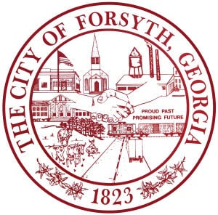

- Call to Order
- Pledge of Allegiance, Invocation, and Roll Call
- Approval of the agenda.
- Special Election
- Election of Presiding Officer
- Forsythia Festival Update
- Approval of the final plat for Luxe Homes of Forsyth, 50 S. Jackson Street
- Appointment to the Convention & Visitors Bureau Authority
- Approval of Requisitions Greater than $6,000
- Industrial Chemicals, Inc.- $17,270.00
- Davis Plumbing Company- $16,736.00

- Water Task Force Update
- City Manager’s Report
- City Attorney Report
- Mayor’s Report
- Additional Business
- Public Comments
- Executive Session (if necessary)
- Adjourn
Individuals with disabilities who require certain accommodations to allow them to observe and/or participate in this meeting, or who have questions regarding the accessibility of City Hall can contact the City Clerk, Shayla Furlow at 478-994-5649 or sfurlow@cityofforsyth.com. If additional accommodations are needed requests should be made as soon as possible but no less than 24 hours prior to the scheduled meeting.

