Agenda
Forsyth City Council Meeting
December 1, 2025
23 East Main Street @ 6:00 p.m.

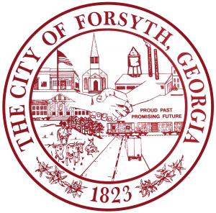

- Call to Order
- Pledge of Allegiance, Invocation and Roll Call
- Approval of the agenda
- Approval of the minutes from the council meeting held on November 17, 2025.
- Tabled Agenda Item from November 17, 2025 council meeting.
- Library Board Appointment
- The Baldwin Group
- Public Hearing for text amendments to the Zoning Ordinance related to Adult Day Programs and first reading
of the Ordinance.
- Second reading of the Annexation and Zoning for tax parcel 041 013.
- Approval of the off-system energy sales margins and voluntary deposits
- Middle Georgia Regional Commission Council Appointments- Monroe County
- Approval of Requisitions Greater than $6,000
- Liftnow Automotive Equipment Corp. -$14,295.00
- Water Task Force Update

- City Manager’s Report
- City Attorney Report
- Mayor’s Report
- Council Board Reports
- Additional Business
- Public Comments
- Executive Session
- Adjourn

Individuals with disabilities who require certain accommodations to allow them to observe and/or participate in this meeting, or who have questions regarding the accessibility of City Hall can contact the City Clerk, Shayla Furlow at 478-994-5649 or sfurlow@cityofforsyth.com. If additional accommodations are needed requests should be made as soon as possible but no less than 24 hours prior to the scheduled meeting.

