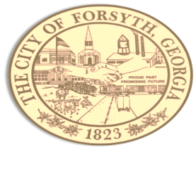
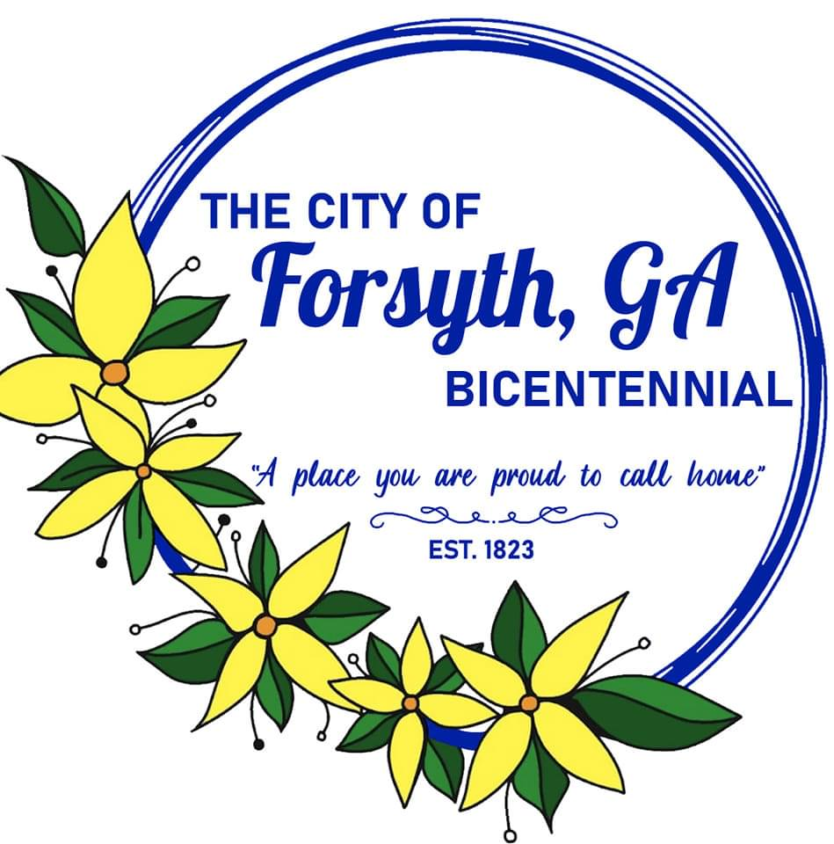
Agenda
Forsyth City Council Meeting
November 6, 2023
23 East Main Street @ 6:00 p.m.

- Call to Order
- Pledge of Allegiance, Invocation by Michael Jones, and Roll Call
- Approval of the agenda.
- Approval of the minutes from the work session and council meeting held on October 16, 2023.
- Public hearing to consider a variance request by Momentum Christian Church, tax parcel 053 029D.
- Public hearing to consider amendments to Article 6 Table 6.2 and Article 28 Section 30.
- Commissioner Davis to discuss Monroe County Senior Center.
- Approval of construction easement for Monroe County, GA for the Project Old Brent Road Storm Drainage Repair.
- Approval of management agreement with Forsyth Country Club.
- Approval of employee Christmas bonuses.
- Approval to reschedule December 4th council meeting.
- Approval of city hall closure requests for the upcoming holidays.
- Approval of unbudgeted purchases for the police department.
- Approval of an unbudgeted purchase for the fire department.
- Approval of TSPLOST intergovernmental agreement.
- 2024 Proposed Budget Review
- Approval of Requisitions Greater than $6,000
- Axon Enterprise $8,707.40
- Davis Plumbing $20,044.00

- City Manager’s Report
- City Attorney Report
- Mayor’s Report
- Council Board Reports
- Additional Business
- Public Comments
- Executive Session
- Adjourn
Individuals with disabilities who require certain accommodations to allow them to observe and/or participate in this meeting, or who have questions regarding the accessibility of City Hall can contact the City Clerk, Regina Ivie at 478-994-5649 or rivie@cityofforsyth.com. If additional accommodation is needed requests should be made as soon as possible but no less than 24 hours prior to the scheduled meeting.

