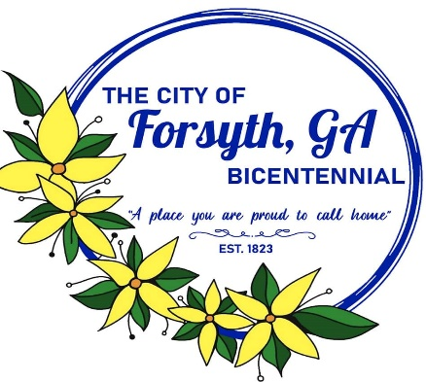
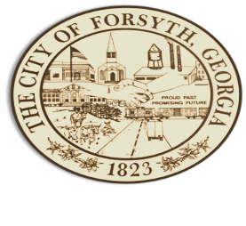
Agenda
Forsyth City Council Meeting
November 20, 2023
23 East Main Street @ 6:00 p.m.

- Call to Order
- Pledge of Allegiance, Invocation by Carol Cook, and Roll Call.
- Swearing in of Councilman Charles Wilder Jr.
- Approval of the agenda.
- Approval of the minutes from the council meeting held on November 6, 2023.
- Approval of Georgia Environmental Finance Authority loan resolution and all documents related to the loan.
- Public Hearing to consider a variance request regarding Article 6, Conventional Residential Zoning, Table 6.2; tax parcel F19 091.

- Public Hearing to consider an application for rezoning by Kason Investments, Inc; Kathy Rowland for tax parcel F35 027A.

- Approval of parade and police escort request by Lois Allen for November 21, 2023.

- Approval of an alcohol license application for Ramdev Hospitality LLC dba LaQuinta Inn & Suites.
- Approval of off system energy sales margins for the power supply year 2024.
- Approval of engagement letter with Charles Grinstead for continued CPA services.
- Public Hearing for the 2024 proposed budget.
- Approval of parking and sidewalk closure request by Victor Hunt.
- Approval of unbudgeted purchase for the police department.
- Approval of Requisitions Greater than $6,000
- Power DMS, Inc. $7,596.61
- Davis Plumbing $19,925.00
- Gresco Utilities Supplies $7,526.75
- Gresco Utilities Supplies $14,055.00
- Industrial Chemicals, Inc. $14,850.00
- City Manager’s Report
- City Attorney Report
- Mayor’s Report
- Additional Business
- Public Comments
- Executive Session
- Adjourn
Individuals with disabilities who require certain accommodations to allow them to observe and/or participate in this meeting, or who have questions regarding the accessibility of Aldermen Hall can contact the City Clerk, Regina Ivie at 478-994-5649 or rivie@cityofforsyth.com. If additional accommodations are needed requests should be made as soon as possible but no less than 24 hours prior to the scheduled meeting.

