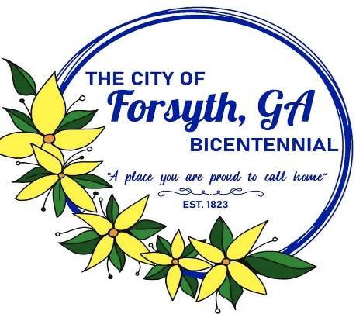
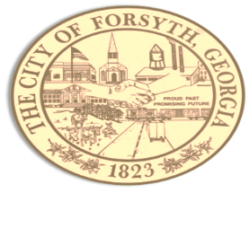

Agenda
Forsyth City Council Meeting
October 2, 2023
23 East Main Street @ 6:00 p.m.

- Call to Order
- Pledge of Allegiance, Invocation by Marilyn Tucker, and Roll Call
- Approval of the agenda.
- Approval of the minutes from the council meeting held on September 18, 2023
- Approval of the final plat for Fox Run Subdivision.
- Approval of a rezoning request by Trio Flex LLC, Matthew Wilds; tax parcel 054 010C.
- Approval of a variance request by Trio Flex LLC, Matthew Wilds; tax parcel 054 010C.
- Approval of a city initiated rezoning request of parcel 027 018 owned by H&H Timberlands.
- Approval of request for transfer of retail electric services.
- Approval of proposed personnel policy manual updates.
- Approval of unbudgeted police department purchase requests:
- MPH Industries $14,383.00
- McLaggan Communications & Radar Service, Inc $19,785.00
- Gulf States Distributors $12,368.83
- Ed’s Public Safety $26,221.00

- Approval of Requisitions Greater than $6,000
- Lenslock $15,192.00

- City Manager’s Report
- City Attorney Report
- Mayor’s Report
- Council Board Reports
- Additional Business
- Public Comments
- Executive Session (if necessary)
- Adjourn
Individuals with disabilities who require certain accommodations to allow them to observe and/or participate in this meeting, or who have questions regarding the accessibility of City Hall can contact the City Clerk, Regina Ivie at 478-994-5649 or rivie@cityofforsyth.com. If additional accommodations are needed requests should be made as soon as possible but no less than 24 hours prior to the scheduled meeting.

