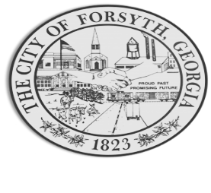
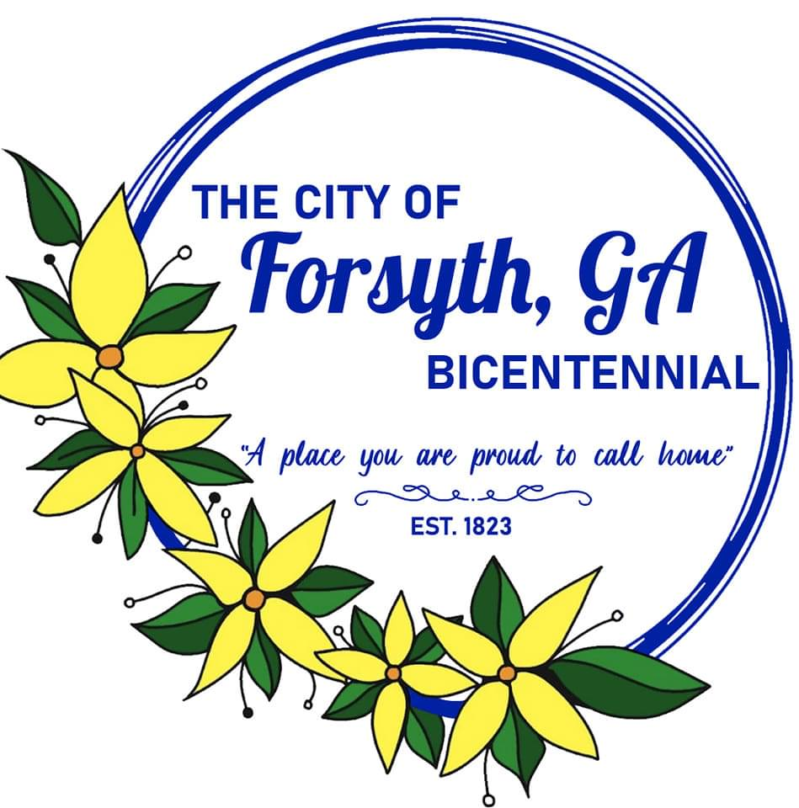
Agenda
Forsyth City Council Meeting
October 16, 2023
23 East Main Street @ 6:00 p.m.

- Call to Order
- Pledge of Allegiance, Invocation by Carol Cook, and Roll Call
- Approval of the agenda.
- Approval of the minutes from the council meeting held on October 2, 2023.
- Public hearing to consider an ordinance amending Section 4-504 of the City Alcohol Beverage Code.
- Eagle Scout project proposal by James Pippin.
- Greg Boike, Director of Planning & Public Administration to review current compensation structure for external equity.

- Review of 2022 Annual Comprehensive Financial Report by Justin Elliot, CPA with Mauldin & Jenkins.
- Approval of Electric Cities of Georgia request regarding a portion of Mahala Drive.
- Approval of Economic Development Department Conversion.
- Approval of street closure requests for remaining 2023 Main Street Events.
- Approval of a street closure request for the Hometown Holiday Parade on November 30, 2023.
- Approval of legal agreements related to United States Department of Agriculture funding.
- Housing Authority appointments by Mayor Wilson.
- City Manager’s Report
- City Attorney Report
- Mayor’s Report
- Additional Business
- Public Comments
- Executive Session (if necessary)
- Adjourn
Individuals with disabilities who require certain accommodations to allow them to observe and/or participate in this meeting, or who have questions regarding the accessibility of Aldermen Hall can contact the City Clerk, Regina Ivie at 478-994-5649 or rivie@cityofforsyth.com. If additional accommodations are needed requests should be made as soon as possible but no less than 24 hours prior to the scheduled meeting.

