**Agenda**

**Forsyth City Council Meeting**

**January 21, 2025**

**23 East Main Street @ 6:00 p.m.**

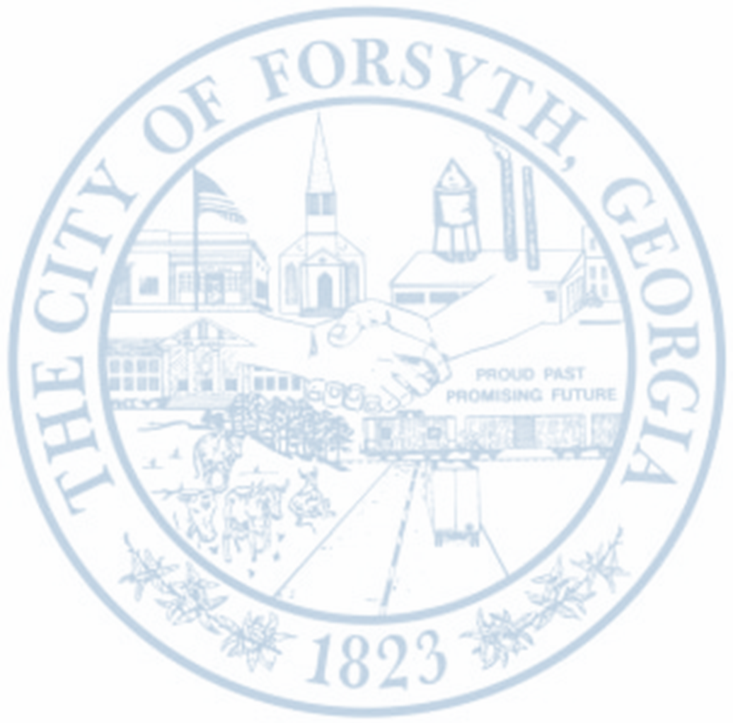

1. **Call to Order**
2. **Pledge of Allegiance, Invocation, and Roll Call**
3. **Approval of the agenda.**
4. **Approval of the minutes from the council meeting held on January 6, 2025.**
5. **Preliminary Plat Review for Heritage Place, 644 Montpelier Road, Parcel 054 022A**
6. **Walter Goodson**
7. **Pachacutec Yupanqui**
8. **City Manager’s Report**
9. **City Attorney Report**
10. **Mayor’s Report**
11. **Additional Business**
12. **Public Comments**
13. **Executive Session**
14. **Adjourn**

**Individuals with disabilities who require certain accommodations to allow them to observe and/or participate in this meeting, or who have questions regarding the accessibility of City Hall can contact the City Clerk, Shayla Furlow at 478-994-5649 or sfurlow@cityofforsyth.com. If additional accommodations are needed requests should be made as soon as possible but no less than 24 hours prior to the scheduled meeting.**